1. The Form, please double click “\bin\Debug\UninstallOffice.exe”

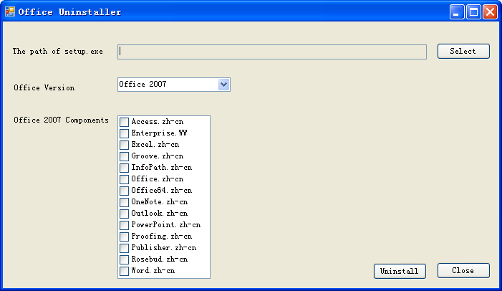

2. Select the path of setup.exe

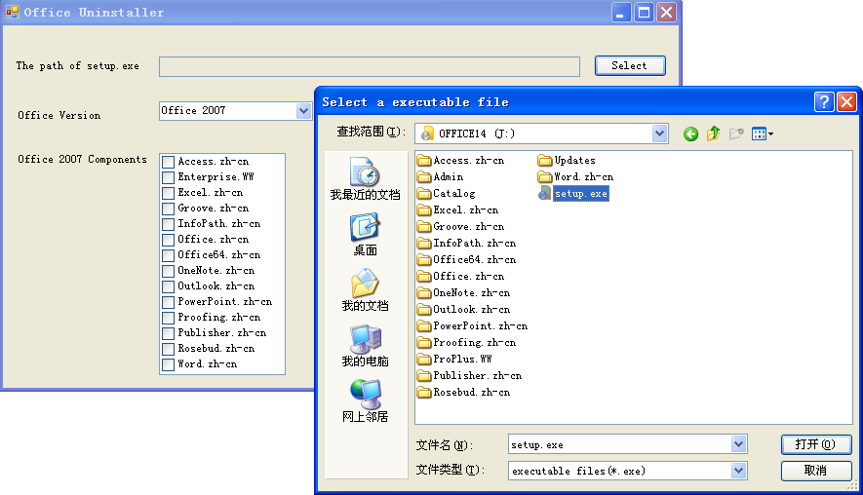

If you choose the wrong file, when you click Uninstall button, you can see the hint show in the follow picture.

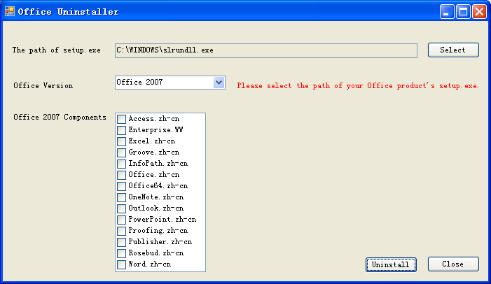

3. You can choose the components you want to remove in the checkbox list.

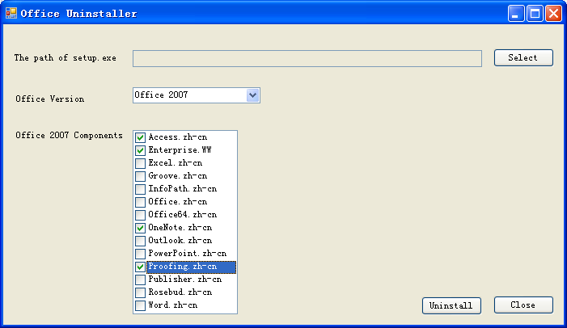

4. When you are ready, you can click Uninstall button, if there are no error detected, the program will execute the uninstall commands.